**Adding Product and Viewing Inventory**

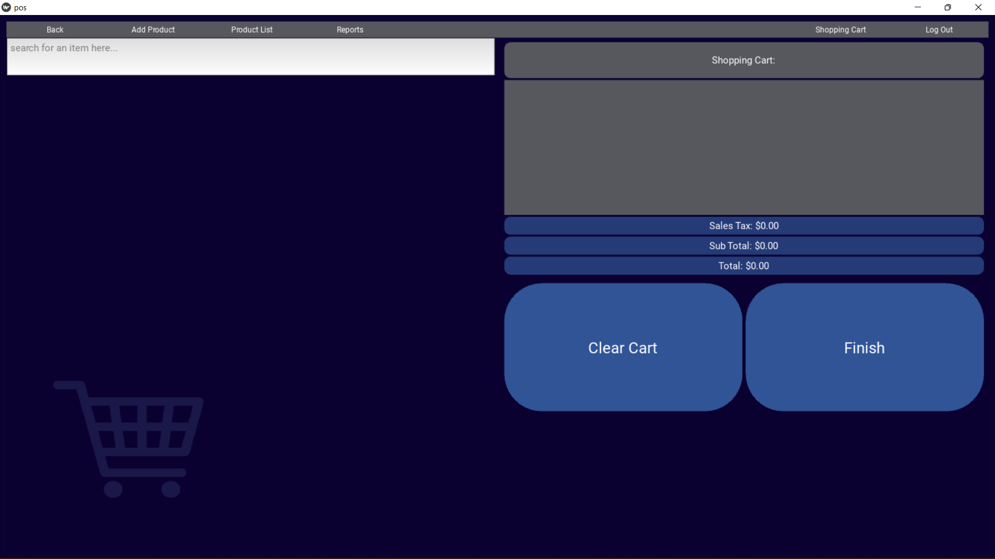

For store managers/employees who would like to update their current inventory, find and select the ‘**Add Product**’ button shown on the POS main screen.

*Exporting a Template*

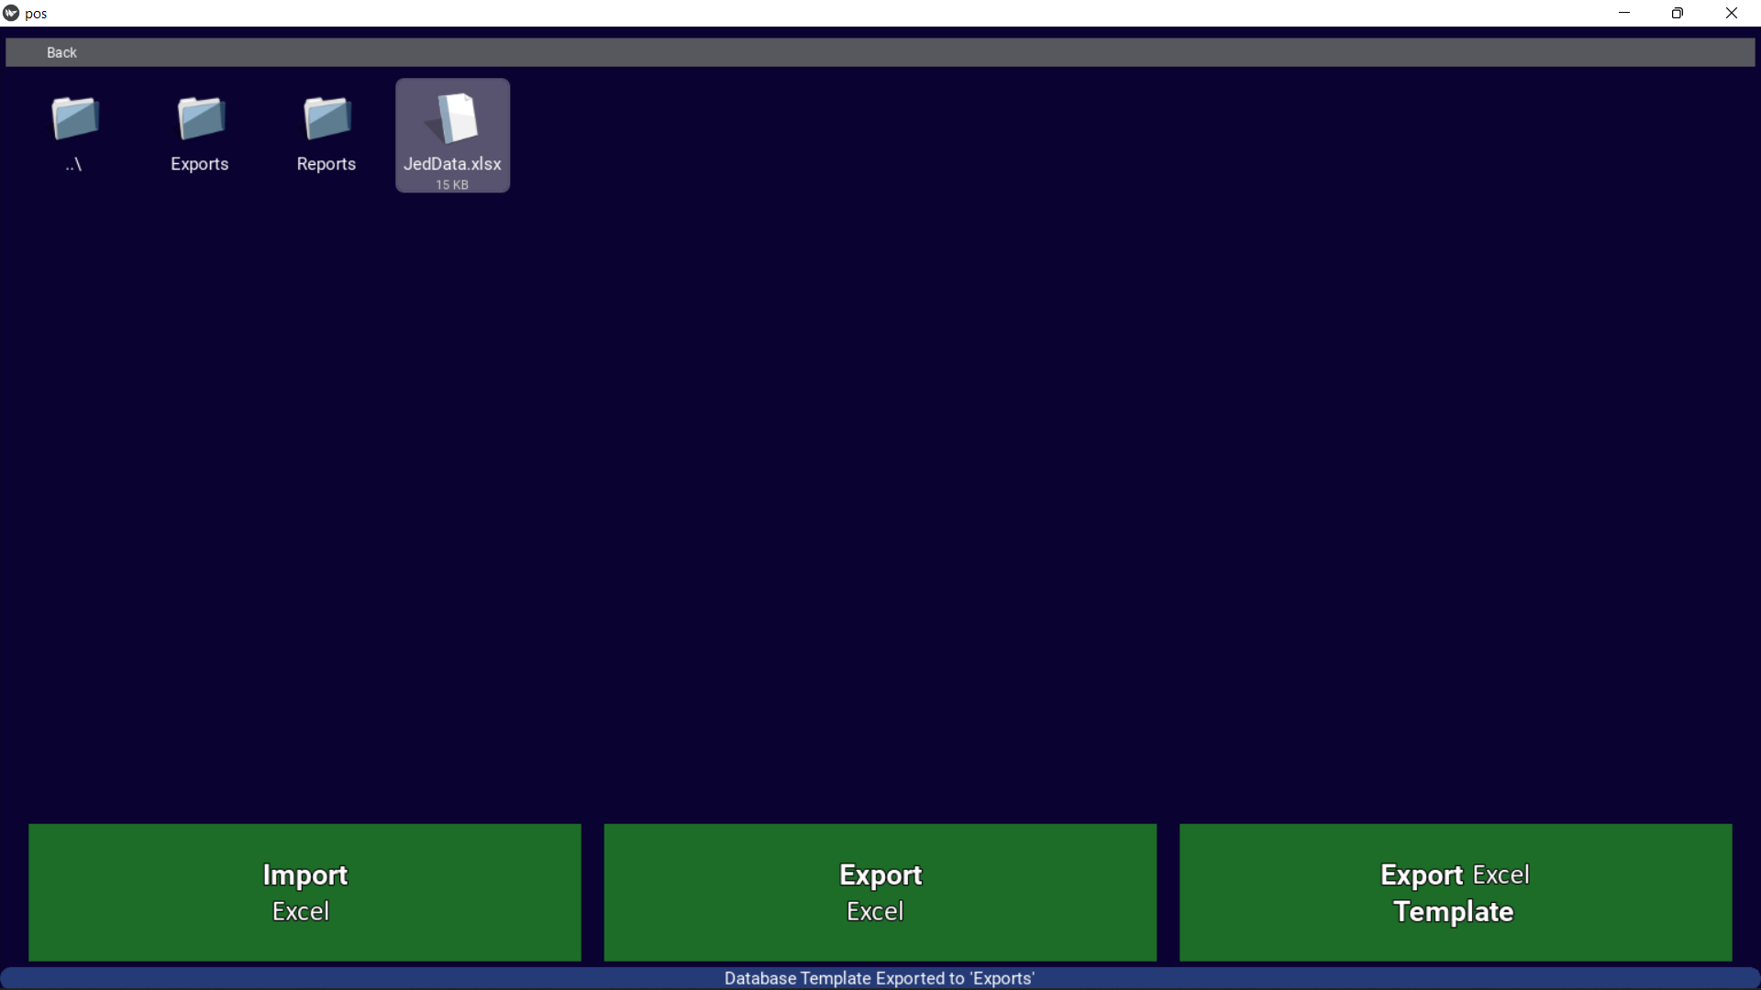

When uploading your store’s inventory for the first time, click the ‘**Export Excel Template**’ button. Look for a message below to confirm a template has been created. The exported excel file will be titled ‘**TemplateFile**’ and can be found in our program’s file directory under:

POS-system-main

🡪 Inventory

🡪 Exports

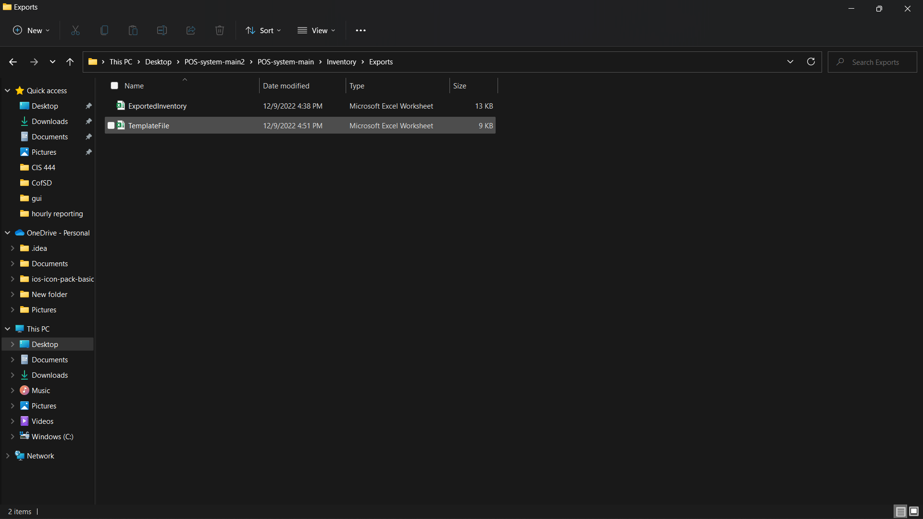

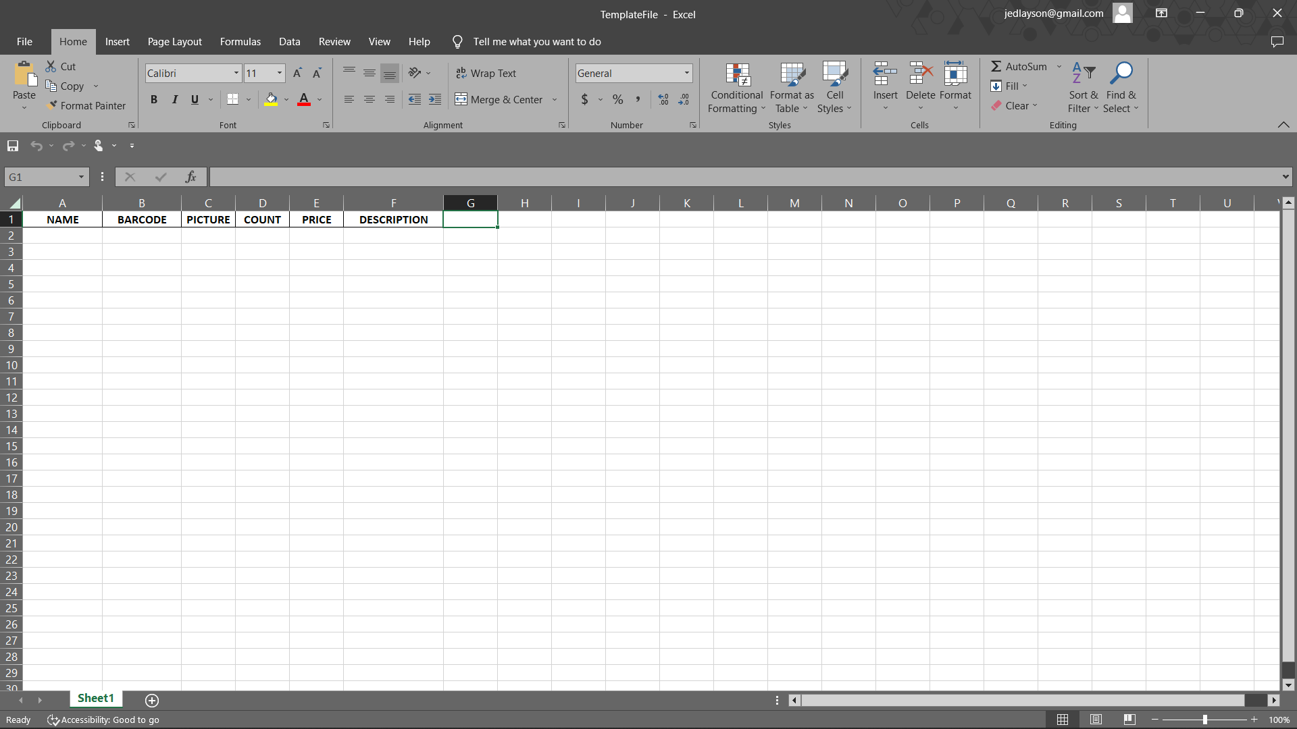

Using this Excel file, users can manually enter or edit the necessary information of their products. In this example, the Excel file below has been filled out, renamed *JedData*, moved outside of the ‘**Exports’** folder, and into the ‘**Inventory’** folder of the program.

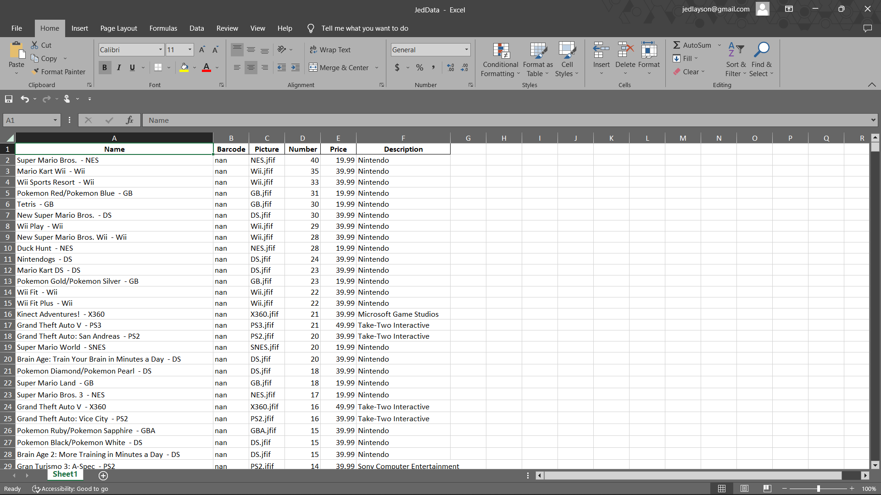

*Importing an Excel File*

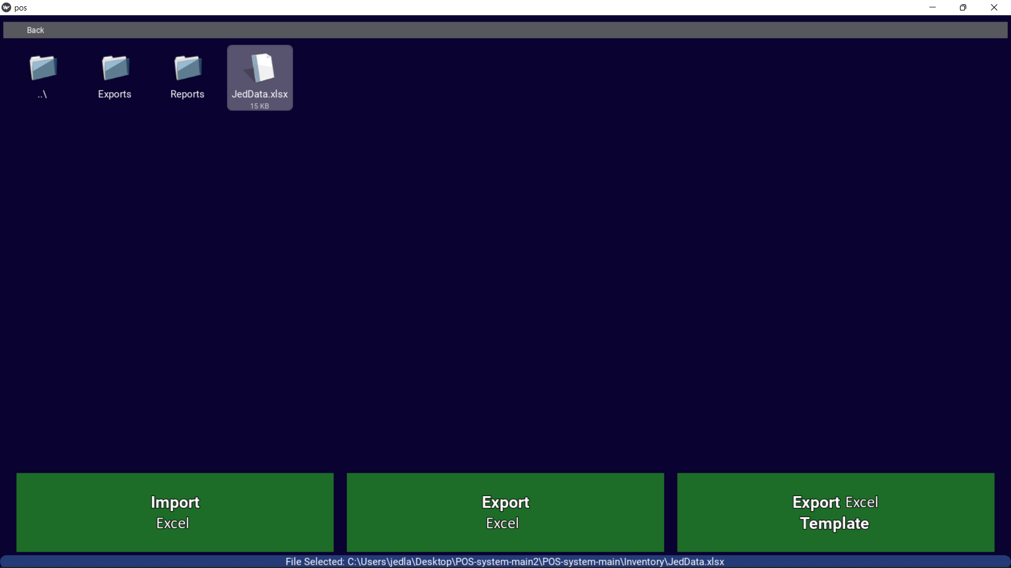

Back in the ‘**Add Product**’ section of the POS, use the program’s built in file explorer to find and click the file you’ve created. For your convenience, the file explorer begins from your ‘**Inventory’** folder. A message will appear at the bottom of the screen for you to confirm you’ve selected the correct file. Next, click the ‘**Import Excel**’ button to import your updated inventory to the POS database. A new message will appear at the bottom of the screen to confirm your Excel file has been imported. Your updated inventory will take effect with a restart of the application.

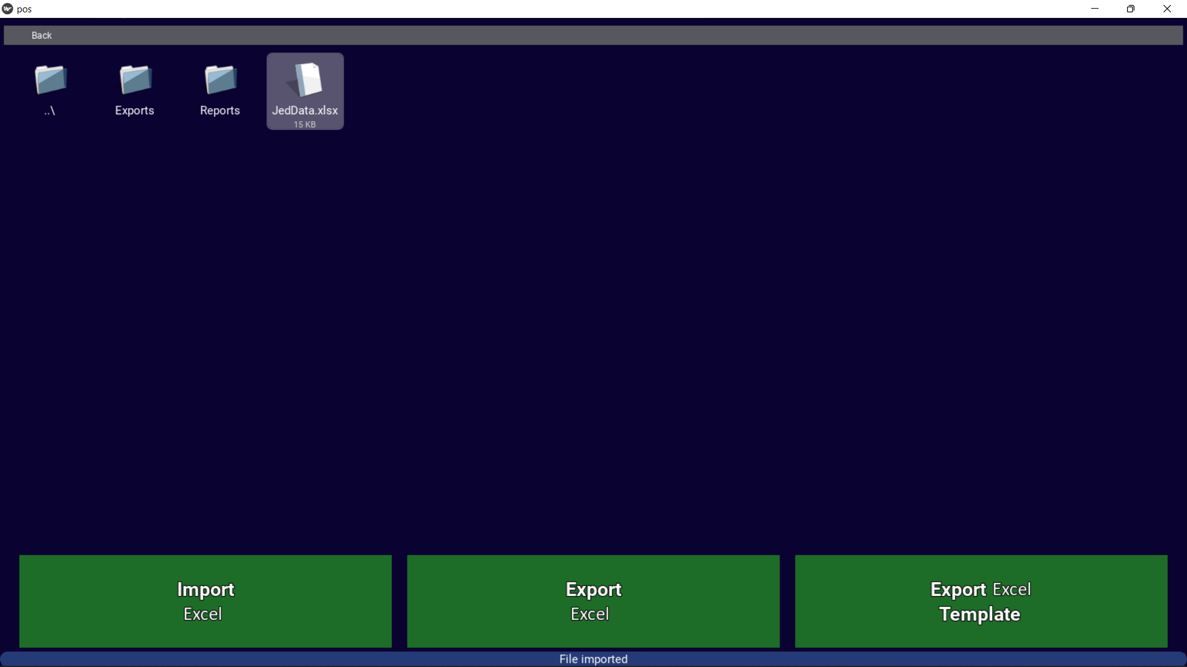

*Exporting an Excel File*

To get an up-to-date spreadsheet of your current inventory, simply press the ‘**Export Excel**’ button. A confirmation message will be shown below, and your exported Excel file will, like your template file, be saved to your ‘**Exports**’ folder under the name ‘**Exported Inventory**’.

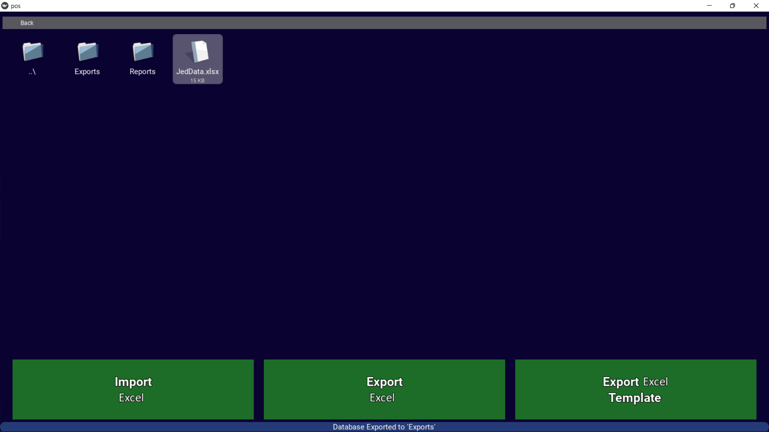

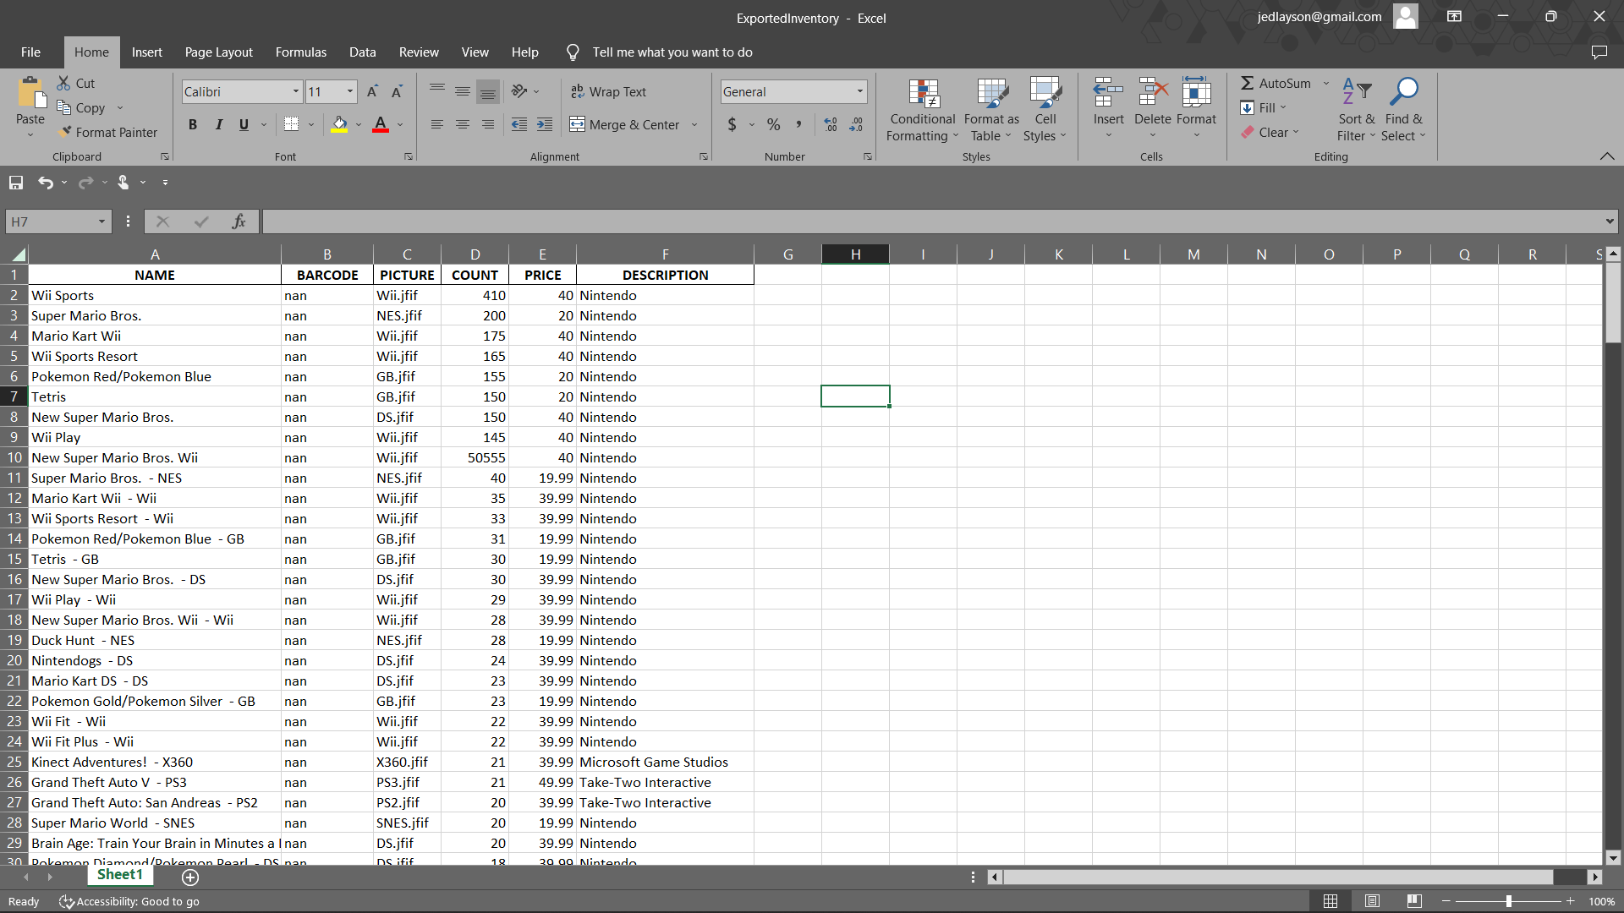

*Viewing your Products*

To view your current inventory, simply find and click the ‘**Product List**’ button on the POS main screen.



The ‘**Product List**’ page will show an organized table of your current inventory, showing your items’ ID, Name, Number (inventory count), Price and Description. The program defaults to 10 items (rows) appearing at a time, and users can move through pages, or change the number of items on a single page at the bottom of the table. Future updates will include the ability to sort your inventory table by any of it’s columns (ex: Name, Number, or Price).

